Directions for preparing and administering Sage SALG-M — 5 March 2012
The Student Assessment of Learning Gains (SALG) instrument is a well-developed survey for measuring students’ learning gains from college courses. We developed a special version of the SALG for undergraduate mathematics courses using Sage, which we call the Sage SALG-M. This instrument is based on the SALG-M instrument, which was developed for undergraduate mathematics courses. The Sage SALG-M instrument (and other SALG instruments) are housed on the www.salgsite.org web platform, which offers a suite of online tools that enable you to customize and administer the survey and gather anonymous responses from your students. Through the platform’s database tools, survey results are available in both summarized and spreadsheet formats.
Please use only Chrome, Safari, or Firefox when accessing www.salgsite.org. Internet Explorer doesn’t support all aspects of the website.
The survey may be used for formative assessment—understanding how your students are responding to your course—or for more formal, summative assessment, such as in our current study of a four-campus initiative on inquiry-based learning in undergraduate mathematics. It may be used with any teaching style but may be particularly useful for those using or experimenting with innovative classroom methods such as Sage.
Please save this document and follow these directions to navigate your way to the Sage SALG-M and set up your own version using the salgsite “wizard” tool. Use Next and Back buttons to move through the wizard screens.
- Go to www.salgsite.org in your web browser (Chrome, Safari, or Firefox).
- Create an account by clicking on Register as a new user link. Fill out the information at the link. If you already have an account, log in as a returning user.
- Once you have logged in, click on Create a new instrument using the wizard to guide me.
- Fill out the information on the “Course Description” page and press Next.
- For “Validating student identities,” press Open enrollment.
If you want to know who has completed the survey (you will not know what they said)—for example, to give extra credit points for completing it—choose Authenticate ID.
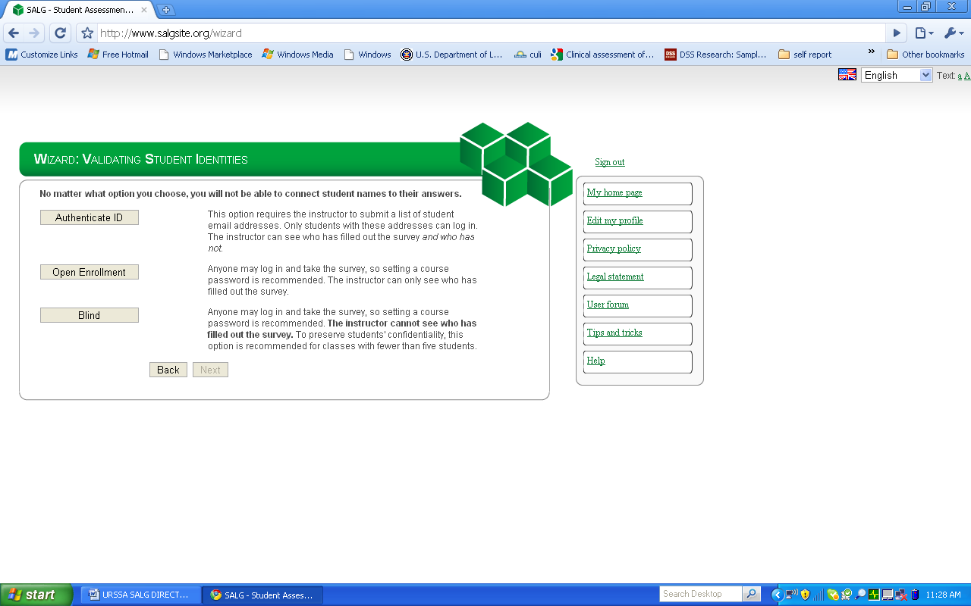

- Select a course password. Students will use this password to log on to the survey. Press Next.
- Select one of the three options (Public, Anonymous or Private) for sharing your instrument with other users.
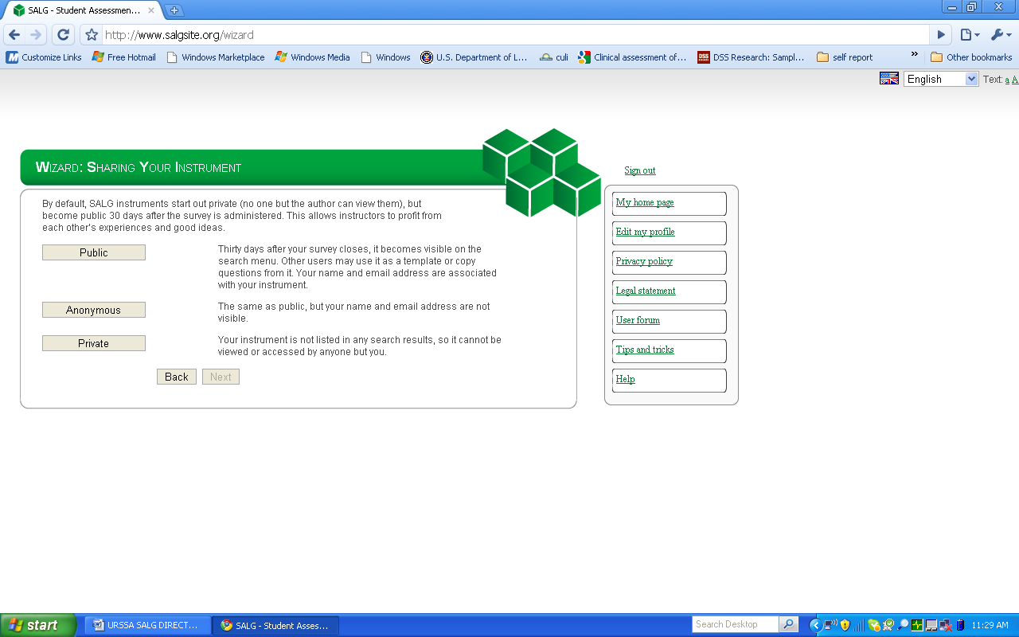

- Under “Choose Baseline or SALG,” choose SALG.
- Under “Choose SALG source,” choose Reuse someone else’s instrument.
- In the search box, enter “Sage SALG-M MASTER” (type in the quotation marks, too) and return. Scroll down, and select Sage SALG-M MASTER; press Preview.
- Press Next at the “Preview” page.
- At the “Choose copy options” page, press No, skip this step.
- At “Edit questions,” you may add your own questions in any existing group by clicking on Add sub question at the top of that group. Make sure you press Save and done when you are happy with your survey. We ask that you do not delete any of the current questions, so that we can more readily compare and discuss student responses.
- Set start and end dates when you will administer the survey to students. Warning: you will not be able to edit your survey after the start date. If you are reviewing the Sage SALG-M and not ready to administer to a real group of students, just enter dates in the future, and modify them later.
- Announce the survey to your students by editing one of the announcement options. This will bring up your e-mail application. If you do not want to send out the message immediately, save a draft in your e-mail system.
- Press Done to return the home page listing all of your SALG instruments. You can continue working or Sign out.
- To access the results of your survey after the students have taken it, log back onto the site, and choose your instrument from the list of instruments. Click on Analysis.

